August 26th, 2007
Hi
Not that much to write about this week; the only lines in my diary related to exercise!
The Netscape mail has out of action for a day or so (I note the same thing happened this time last year). They said there was a problem but I think it was just to make slight changes to the format.
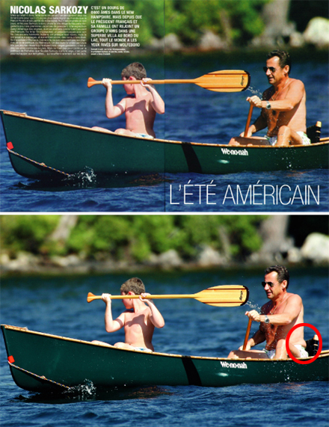
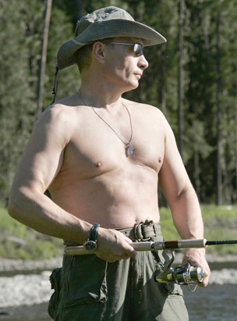
The only thing that interested me during the week were the reports about the French and Russian presidents who were photographed with bare torsos while on holiday. Apparently, the original picture of Sarkozy was touched up before being published to remove a layer of fat around his waist. Putin however was quite different; for a 54-year-old he is well built and his picture went over well in Russia. It was also printed on the front page of a newspaper with arrows pointing to each set of muscles and a step-by-step guide on exercises to do to get a body like the president’s.

That’s about it for this week.
Cheers

